

**ALY****6080: Integrated Experiential Learning**

**Instructor: PROFESSOR MAX MASNICK**

**June 24th, 2020**

**Submitted By:**

**Reetika Chaturvedi**

**DESCRIPTION**

This XN project gave me an opportunity to deep dive into the skills offered by CPS in three programs (i.e. Project management, Leadership and Sports leadership) and try to map skills as per the job market requirements. This will enable CPS to understand how well these skills fit with the target job.

The tasks undertaken by me to deal with this strategic issue are as follows:

1. **Data Visualization (raw data)-** Since I visualize data in order to understand it, the first thing that I did with the given raw data was Visualization. I used Tableau for visualization.
2. **Data Reshaping-** After visualization, I used R as a tool to reshape the data. I converted data into long format using pivot function and thereafter converted it into wide format creating binary variable for each format. Once, I was successful reshaping the data I used the write.csv function to proceed with the analysis from the reshaped data devoid of null values. The libraries that I used for data reshaping includes janitor, tidyverse, dplyr, tidyr.
3. **Visualization (clean data)-** I used R and Tableau to visualize the clean data and to understand it in a better way.
4. **Reading and understanding Peer reviewed articles-** Since our task was to map the course skills and analyze if it was aligning with the job skills, I read various peer reviewed articles. The articles read by me aligned with the task given to us.
5. I read about the critical thinking skills and their importance.

**Citation (Article)-** Cain, H. R., Giraud, V., Stedman, N. L. P., & Adams, B. L. (n.d.). Critical Thinking Skills Evidenced in Graduate Students Blogs. Retrieved from <https://journalofleadershiped.org/jole_articles/critical-thinking-skills-evidenced-in-graduate-students-blogs/>

**Name of the article**- Critical Thinking Skills Evidenced in Graduate Students Blog

1. Also, one of our courses discuss about introduction to digital era and I found an article that states the importance of adopting with the 21st century digitalization.

**Citation (Article)-** Kivunja, C. (2015b). Teaching Students to Learn and to Work Well with 21st Century Skills: Unpacking the Career and Life Skills Domain of the New Learning Paradigm. International Journal of Higher Education, 4, 1-11. Retrieved from  
<http://dx.doi.org/10.5430/ijhe.v4n1p1>

**Name of the article**- Teaching Students to Learn and to Work Well with 21st Century Skills: Unpacking the Career and Life Skills Domain of the New Learning Paradigm.

1. I also read an article stating the importance of capstone projects and the collaboration involved in such projects.

**Citation (Article)-** Additional informationDisclosure statementNo potential conflict of interest was reported by the authors. (n.d.). Merits of capstone projects in an online graduate program for working professionals. Retrieved from <https://www.tandfonline.com/doi/abs/10.1080/03098265.2019.1694874>

**Name of the article**- Merits of capstone projects in an online graduate program for working professionals

These articles gave me a clarity and a deeper understanding of my task.

1. **Brainstorming-** After understanding our data and reading peer reviewed articles, I had a brainstorming session with my team members wherein we formulated two questions each that we would want to figure out, based on our initial research.
2. **Formulation of a Project proposal**- I framed a project proposal wherein I discussed about importance to be given to digital literacy.
3. **Collection of job skills-** This was a difficult task as there are many job sites. I predominantly checked the jobs on NEU Careers related to these three programs. I also collected information from job portals LinkedIn and Indeed. I mainly contributed for project management jobs.
4. **Creation of road map-** I brainstormed with my team and created a roadmap according to our progression with the tasks.
5. **Drafting final proposal-** I drafted a final proposal based on the feedback given by our professor on my previous proposal.
6. **PPT Slides contribution-** I contributed in the visualization slides of our group PPT.

**Note-** In all the reports, we used Google documents and everyone had their own share of work. It was equally divided amongst four members.

**METHOD**

I used a systematic approach to contribute towards this deliverable. I used R for data reshaping and Tableau for visualization part. The things that I had taken care as a responsible member of the team are as follows:

1. Setting personal goals every week that aligned with the team goals.
2. Suggested strategies to attain our team goals.
3. Outlined methods and ways to complete an assignment and made sure to stick to timelines.
4. Effective communication on zoom calls and Microsoft teams. One of our team members is in a different time zone so we made adjustments accordingly.
5. I communicated my expectations in a clear way to my team and also took care of their expectation. We collaborated in an effective way.
6. Completed delegated tasks in a timely manner and have always taken suggestions from the team members.

**VISUALIZATIONS**

Following are the visualizations contributed by me for the final deliverable.

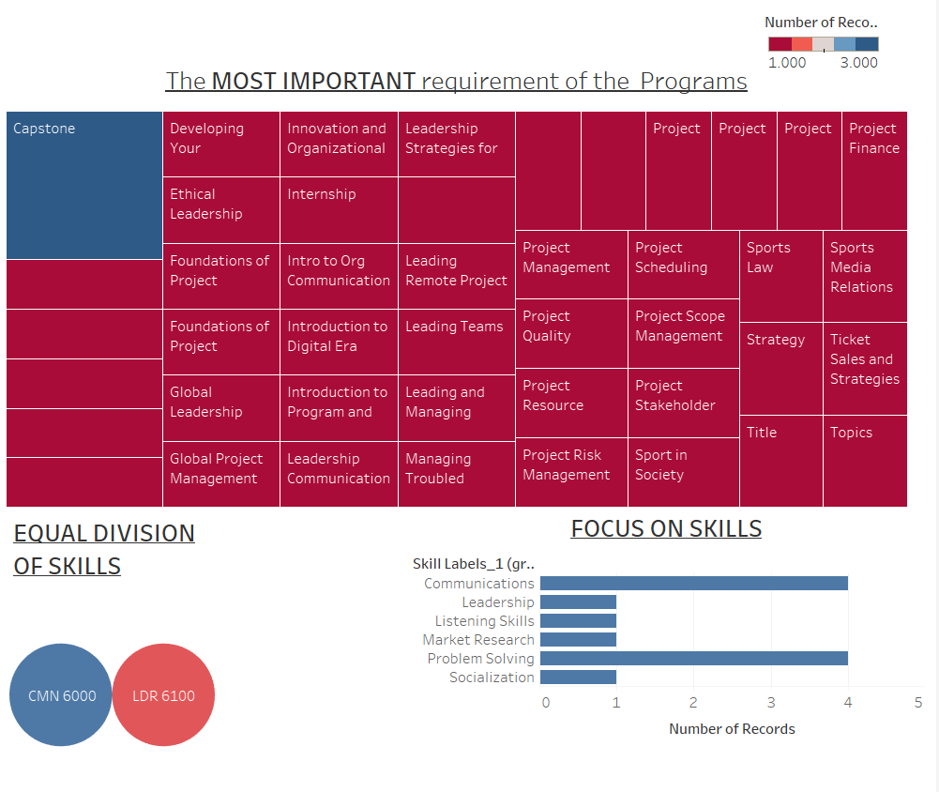EDA visualizations (Raw data using filters on tableau)

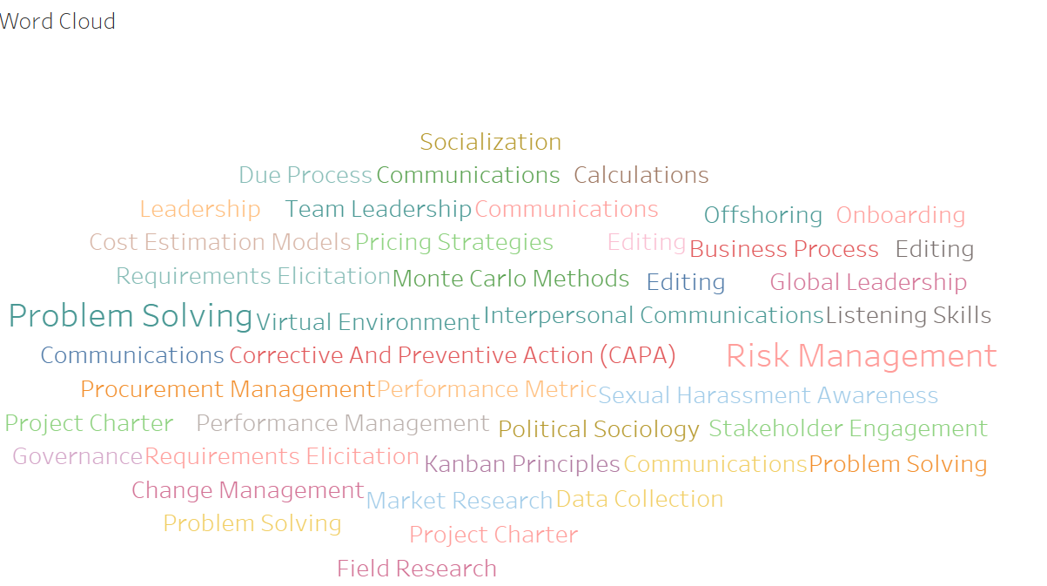EDA of Program outcomes using word cloud and bar charts.

1) **Text analysis**- The words repeated most are problem solving and risk management.

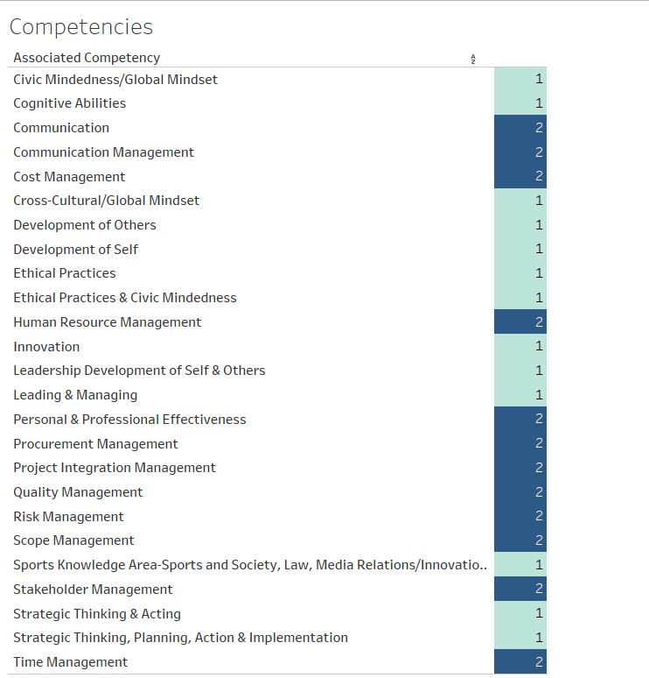2) **Associated competencies associated with each program** (frequency and bar graphs to visualize)

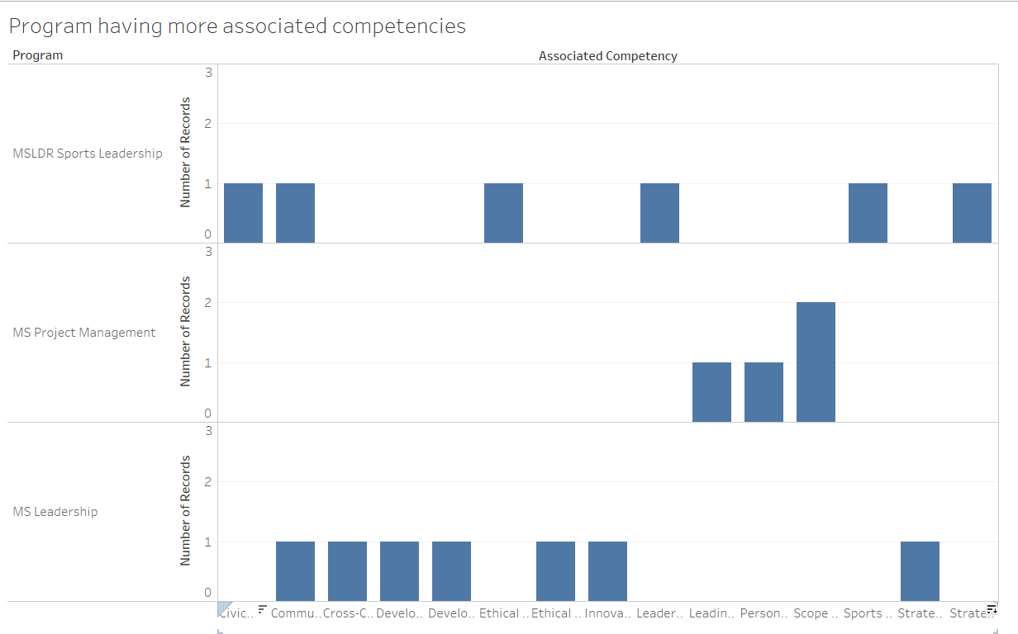

**Visualization done using R code.**

1. 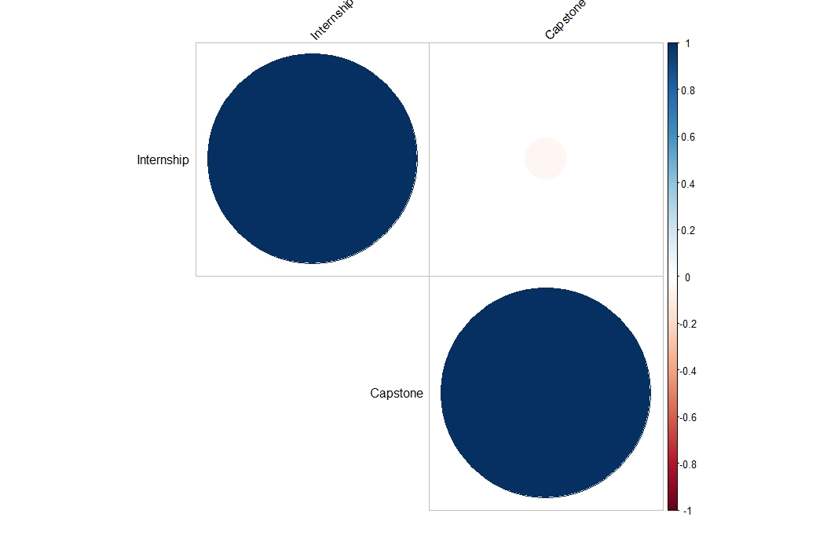Correlation plot to see the relationship between capstone projects and internships.
2. 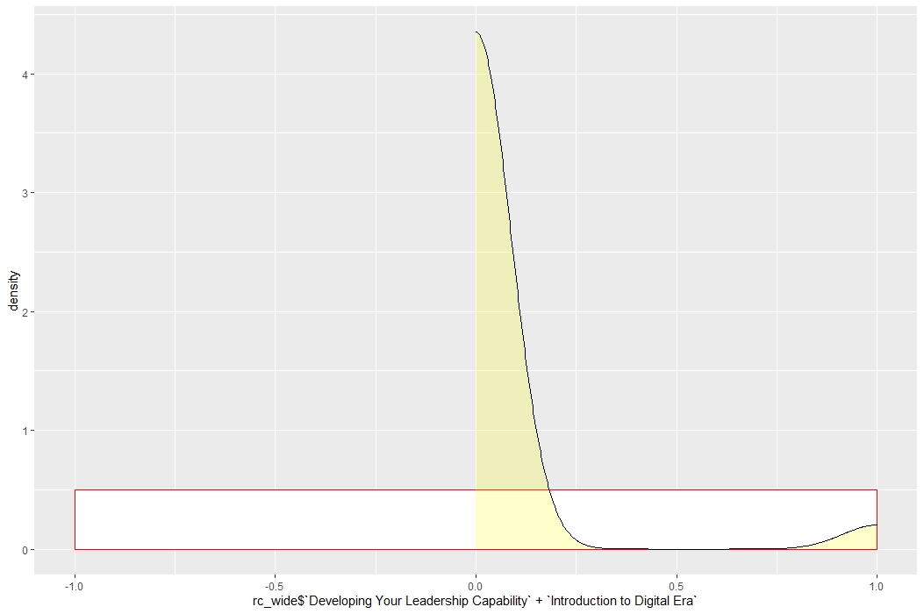Density plot to see the spread of leadership capability and introduction to digital era.

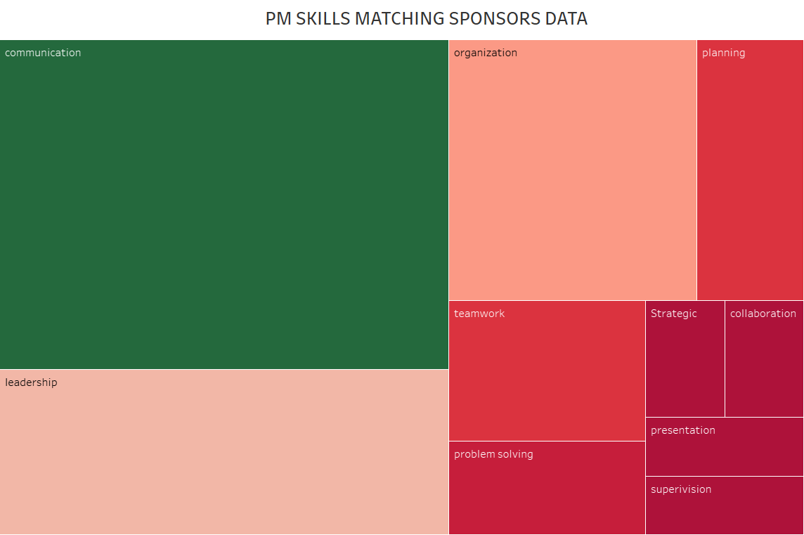Data collected by me of Project management jobs and visualization of the same:

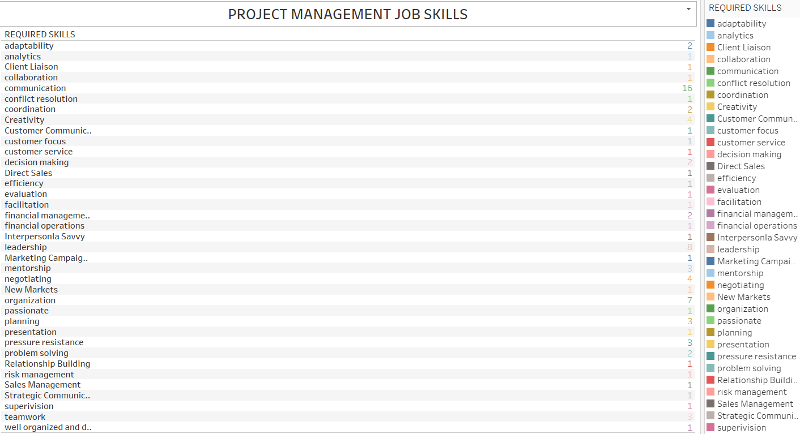Mostly communication skills are focused upon with a count of 16 out of 34 job data collected.

**Road Map For the team**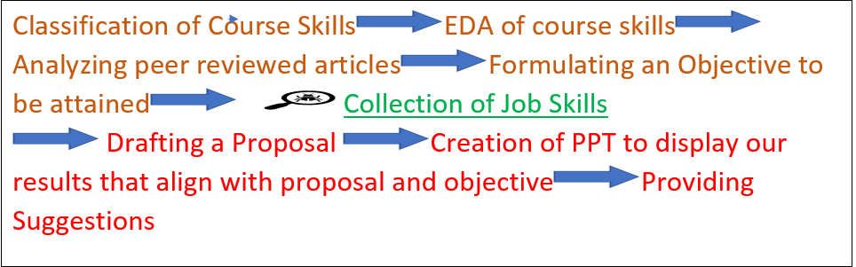

**SUGGESTIONS**

The suggestions given by me:

1. Focus on communication skills in all the programs. (Based on peer reviewed articles and job data)
2. Timeline of XN projects (based on peer reviewed article stating that these projects prepare students for internships, a checklist made by me and getting it filled from 15 students). 12 responded ‘Yes’ as their answer.

|  |  |  |
| --- | --- | --- |
| Question | Response- Yes | Response- No |
| Did the XN Project feedback and learnings contributed in your internship/ co-op. |  |  |
| Do you think taking XN project before internship was useful? |  |  |

**Checklist**

1. Dealing with more digital tools and technologies- (Based on peer reviewed articles)

**Note- Citation of peer reviewed articles based on which I created these suggestions are given in the description by me.**

**I created a zip folder of all my R codes and tableau files, which I am providing as part of my contribution. It has a folder that has the snippets of responses received by me.**